ERROR REPORT LAB 1 EXERCISE

Pradyumna Arjun Paithankar
25MML0035

1. The dataset did not load because the system could not find the folder containing the Speech Commands dataset.
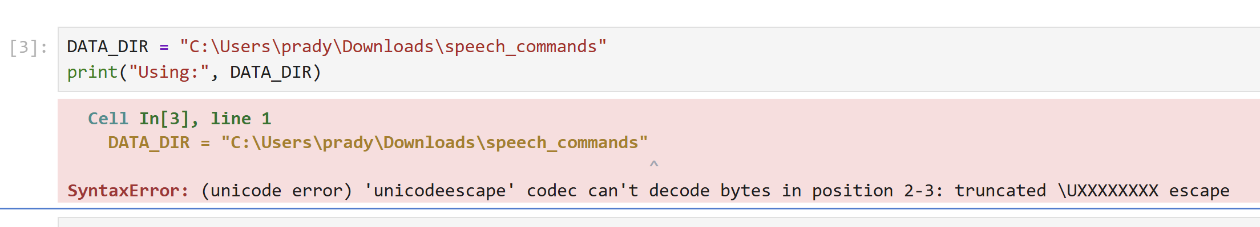

To resolve this issue, I prefaced the string with the letter r. This tells Python to treat the backslashes as literal characters and ignore their special escape meaning.

2. It was not detecting the files properly. Which meant that the files were not getting saved into list in correct format before processing.

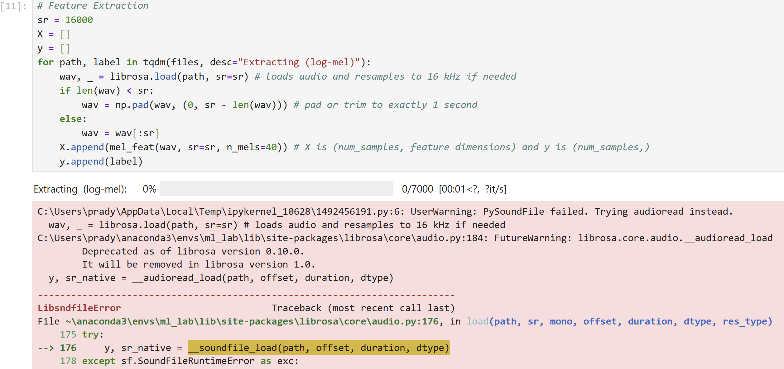
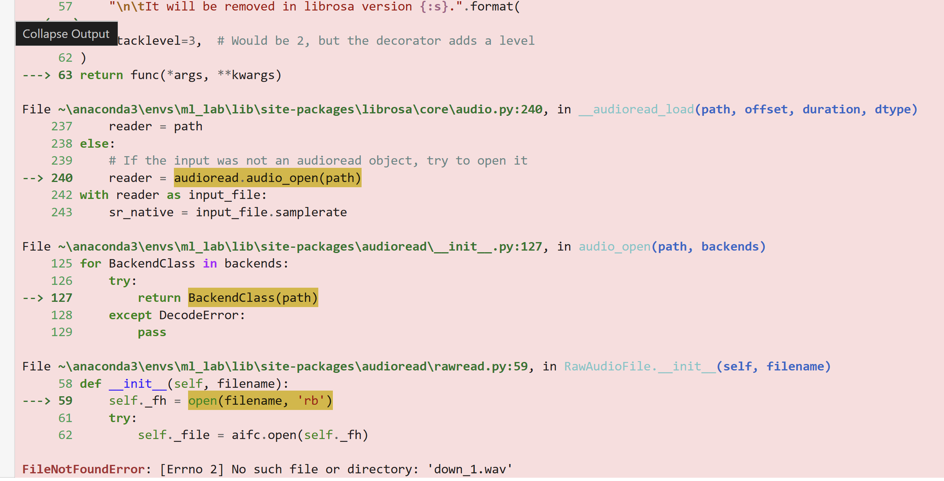

To resolve this issue, I had to change the code of the function list_wavs which generated the list of data items. I corrected the code by joining the filepath and name to search and append in list all the items present in dataset.
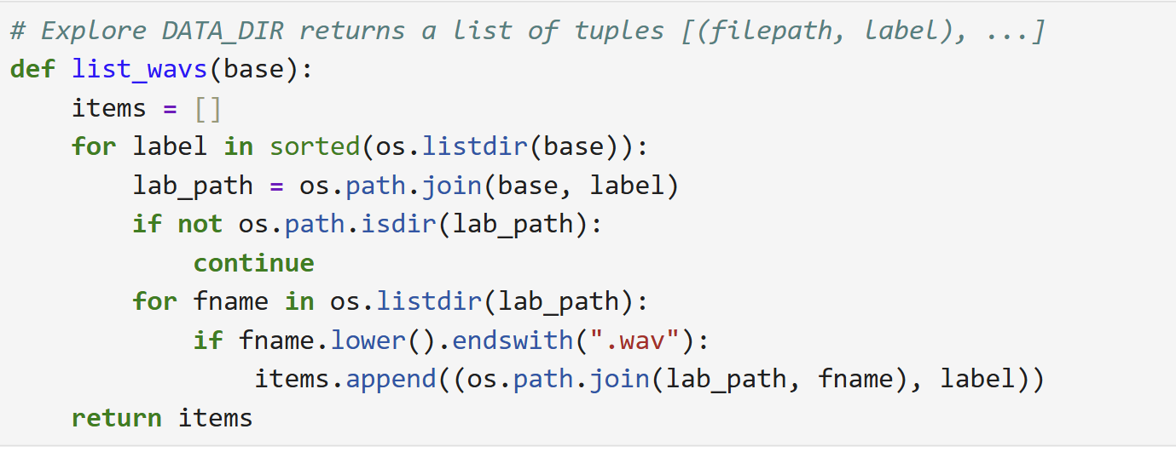

3. The process of generating output was slow when the audio files were more than 16000.
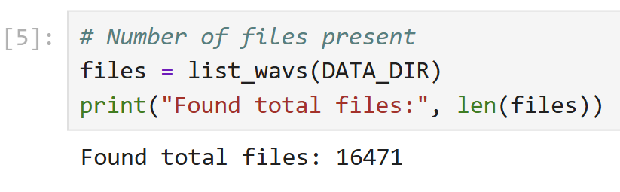

So I had to limit the max files per class by setting a limit of 200 per class. The process ran relatively faster but the accuracy of model was only 72%. To improve this I set the limit to 1000 afterwards which was relatively faster and also improved the accuracy to 83%.
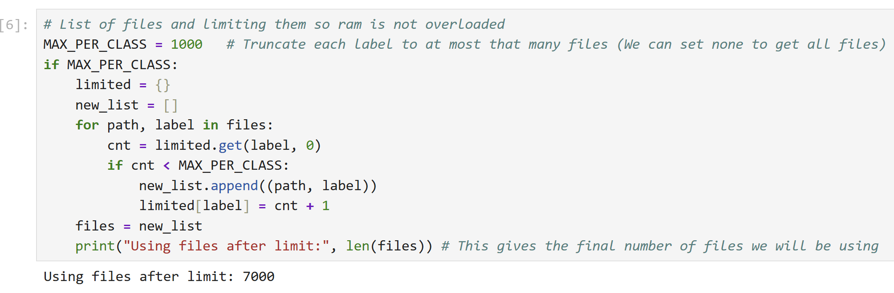

4. Model accuracy was lower than expected.
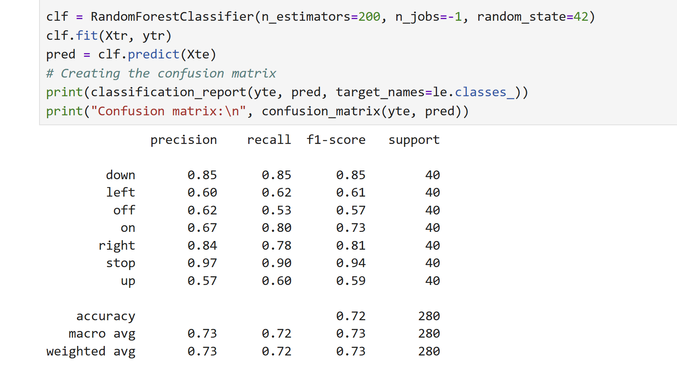

To resolve this problem, I incorporated standard scaler because features were not standardized before training which led to less accuracy.

5. The spectrogram was not displaying correctly and appeared squashed.

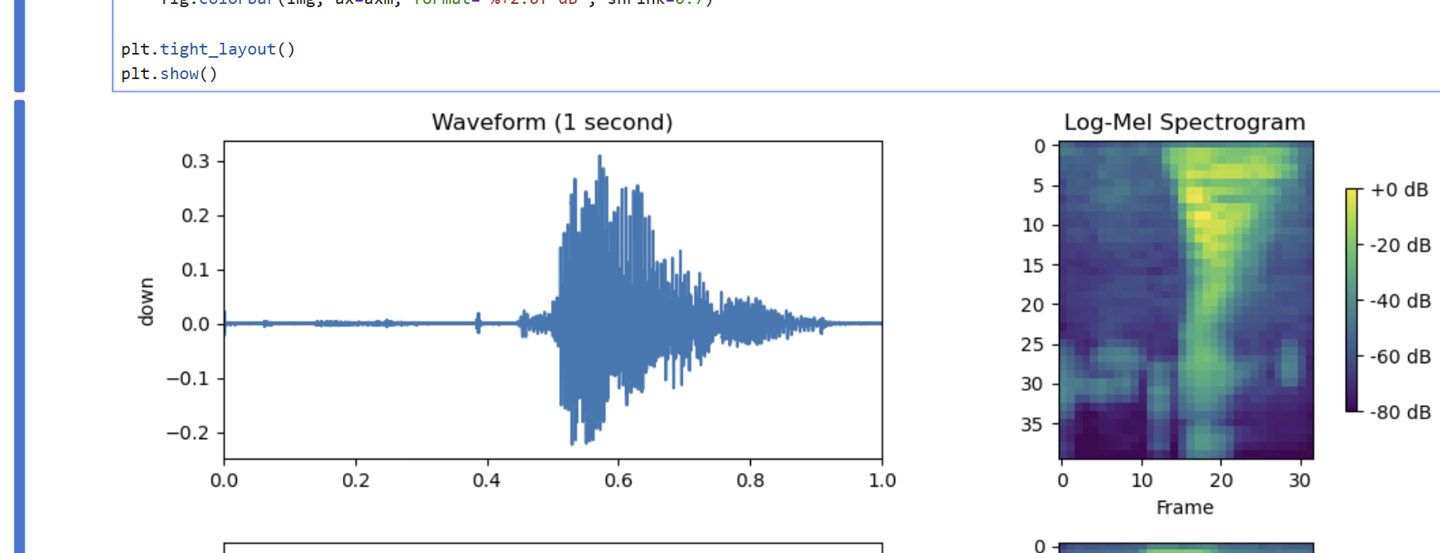

To solve this, I added aspect='auto' and origin='lower' to imshow() method which made the graphs more evenly spaced and better visualization.

